Government Engineering College, Thrissur
CS333– Application Software Development Lab
Documentation -
Exp 10 – Order By, Group By & Having
Exp 11 – Set operators, Nested queries
& Join queries

Date of Submission
9 October 2020

Submitted By
Kowsik Nandagopan D
Roll No 31
TCR18CS031
GECT CSE S5

Experiment 10

AIM
Implementation of Order By, Group By& Having clause.

Description
Implement Order By, Group By& Having clause in MySQL to get valuable insight from the previously created database. Functions available in MySQL are - ORDER BY, GROUP BY & HAVING

Output / Screenshots
Full Table
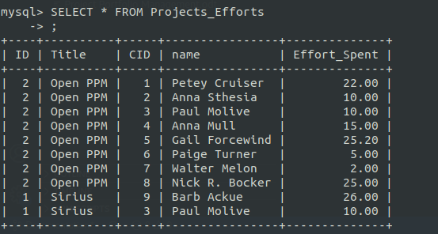
1. GROUP BY - Group By Title Form the Project Effort Views
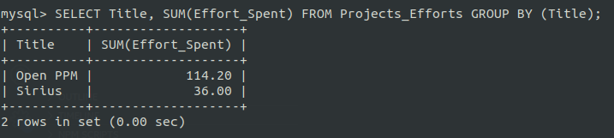
2. HAVING - Group By Title from the Project Effort Views and select the one having the Sum of Efforts greater than 100
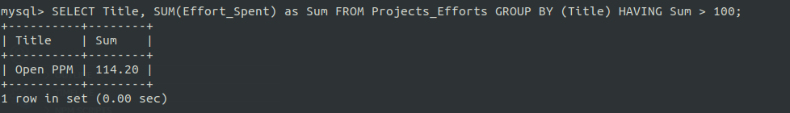
3. ORDER BY - Order the Projects Efforts View in Decreasing Order
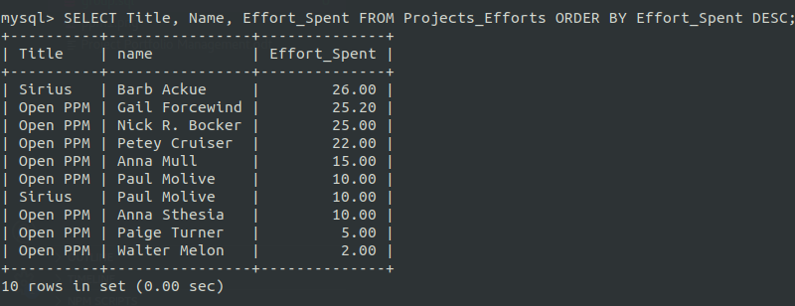

Experiment 11

AIM
Implementation of set operators, nested queries and Join queries

Description
Implement set operators, nested queries and Join queries in MySQL to get valuable insight from the previously created database.
- For union there is UNION operator.
- For Intersection and minus (set difference) may not be available in some MySQL versions so we can use IN or NOT IN respectively.
- For Cross Product there is a function called CROSS JOIN.
- Also for nested queries it is select-from where inside another query.

Output / Screenshots
1. JOIN - Projects Efforts View and Join with the Consultants table and display the phone number corresponding to their efforts
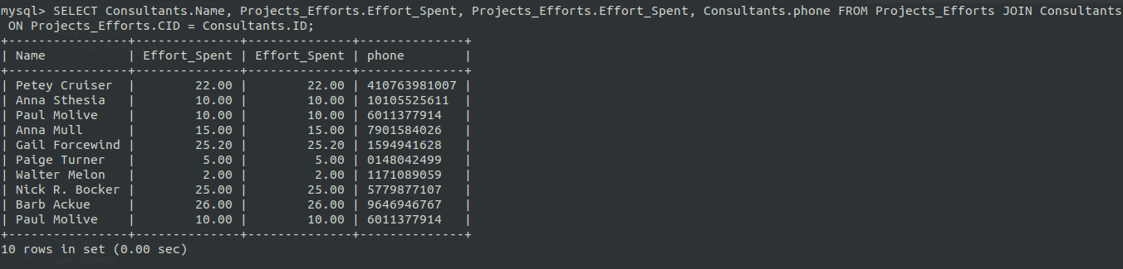
2. Nested Query - Use the nested query and select the CEO From the Project Effots Table and display his Effort
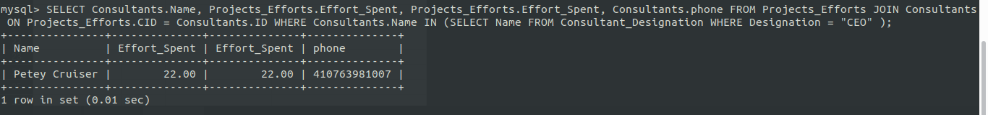

3. UNION - Use the nested query and select the CEO and Marketing Manager From the Project Efforts Table and display his Effort
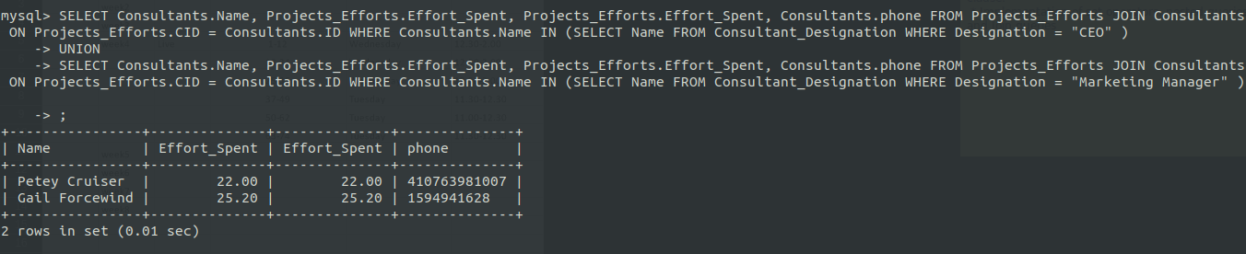
4. Set Difference - Select the name of those working in Open PPM Project not in Sirius. Use Projects_Efforts View
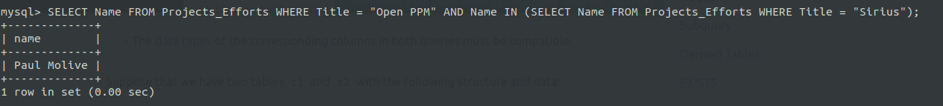
5. Intersection - Select the consultants working on both Open PPM and Sirius. Form Projects_Efforts View
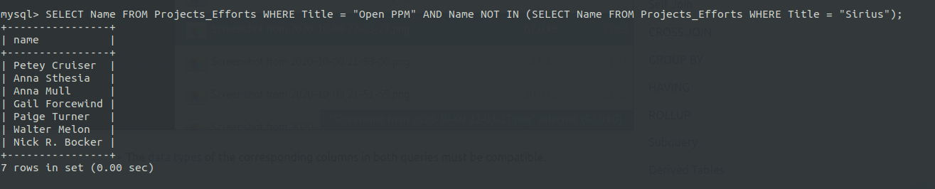
6. CROSS Product - Just See the Cross product on Projects_Effort and Consultants Table
